
Gaskell Community Primary School Annual Governance Statement (2024 – 2025)

Annual Governance Statement for the Governing Board of Gaskell Community Primary School
School Year 2024/2025

Role of the Governing Board

Effective Governance requires governing boards to fulfil their three core functions which are:

Setting Strategic Direction
- Clarity of vision and ethos
- Engaging stakeholders
- Meeting statutory duties

Creating Robust Accountability
- Accountability for teaching, achievement, behaviour, and safety
- Strengthening school leadership
- Performance managing the Head teacher
- Contributing to school self-evaluation

Ensuring Financial Probity
- Solvency and effective financial management
- Use of Pupil Premium and other resources to overcome barriers to learning

Governance Arrangements

The Governing Board of Gaskell Community Primary School is made up of the following Governors:
Parent Governors: Sophia Bibi, Salman Anjum
Staff Governors: Aimee O’Donnell
Co-opted Governors: Naeem Arshad, Sarah Bottomley, Emma Metcalfe, Joanne Booth (left the Governing Board in June,2025) and Terence Hargreaves
Local Authority Governor: Vacancy
Head Teacher: Sarah Barlow

The full Governing Board meets once per term and Governors also meet as committees to consider various aspects of the school in detail. At Gaskell Community Primary School, we have the following committees:

Personnel, Finance and Premises Committee
Curriculum and Pupil Welfare Committee
Head Teacher Appraisal Committee

There are also committees that meet, if required:
Staff Discipline and Grievance Appeals
Pupil Discipline
Complaints
Governors’ Attendance Record

Attending Governing Board meetings is an essential part of a Governor’s role and the attendance record for the Governors of our school is excellent. This ensures that all Governors receive the necessary information all at the same time and therefore important and informed decisions can then be made as and when necessary, on all aspects of the school, staff, and pupils.

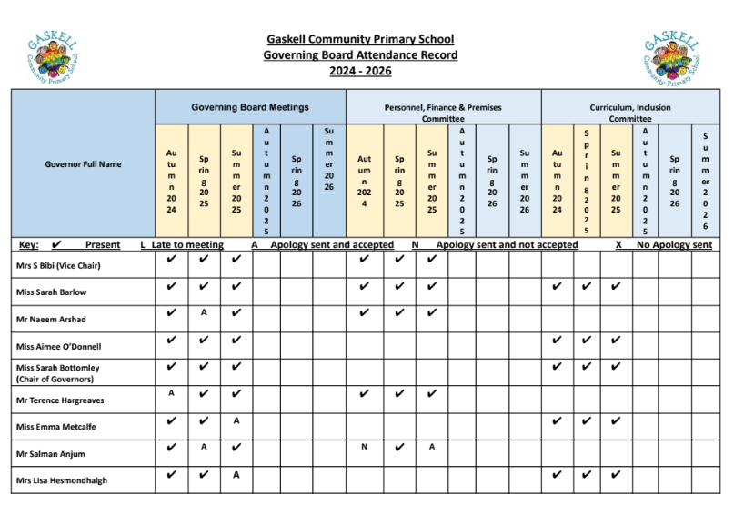
Assessment and Impact of the Governing Board during 2024/2025 School Year
Personnel, Finance and Premises Committee
- Financial Management
- Staff recruitment
- Building developments/improvements
- Health and Safety
The Personnel, Finance and Premises Committee have rigorously scrutinised the school budget, working closely with the School Business Manager and Head Teacher to ensure resources are allocated strategically. By requiring three quotes for purchases over £10,000, we've secured "best value" and improved financial efficiency. This careful oversight has allowed the school to maintain a strong staffing structure.
We have actively supported the school's staffing strategy, including the recruitment and retention of key personnel. This has involved helping to define roles and responsibilities to create a more effective workforce. We were also instrumental in the restructure of the Senior Leadership Team (SLT) to better drive school improvement. This work has been essential in enabling the school to attract high-quality staff and to support their 'grow your own' philosophy.
Our committee has also overseen and supported important building developments and improvements within the inside of school and around the school grounds, including the newly finished school extension. This has ensured projects are completed on time and within budget. We've also reviewed contracts like those for School Building Maintenance, ensuring the school's estate is well-maintained.
Finally, we've prioritised health and safety by having an appointed governor who has worked in tandem with the School Business Manager and Site Team to complete termly health and safety checks and reports, providing a clear and transparent overview of the school’s compliance and site condition.
Curriculum and Pupil Welfare Committee
- School Development Plan
- Governor visits to school focused on SIP areas
- Data analysis
- Attendance
- Behaviour and safety
- Safeguarding

Governors have worked closely with the Head Teacher and senior leaders to monitor the implementation and progress of the School Development Plan. Our committee has been instrumental in holding the school to account, ensuring that key actions are being met and that the plan remains focused on driving positive outcomes for all pupils. This oversight ensures that the school's strategic priorities are not only ambitious but also achievable.

A core part of our work involves governor visits, which are strategically aligned with the School Improvement Plan (SIP) areas. These visits allow us to see the school's priorities in action and to gain a deeper understanding of teaching and learning across different subjects and year groups. Following these visits, we write a report, which is shared with all governors and key staff in school, reviewing key performance indicators to ensure the school is on track to meet its targets. This direct link between classroom observation and data scrutiny provides a powerful feedback loop, enabling the committee to provide informed and effective challenge.

Our committee places a strong emphasis on pupil welfare, with a dedicated focus on key areas such as attendance, behaviour, and safety. We regularly review data on attendance, providing support and challenge to improve rates and ensure all pupils are in school and ready to learn. We also monitor behaviour and safety, ensuring the school's policies are effective and that pupils feel secure and respected. Pupil, staff and parent voice surveys are srutinised to inform strategic decisions, hold leaders accountable for school culture, and identify key areas for improvement.

Safeguarding is our highest priority. The committee, led by our Safeguarding Governor, provides robust oversight to ensure that the school's safeguarding policies and practices are effective and fully compliant. We receive regular reports from the designated safeguarding lead, question any trends, and ensure that all staff and governors receive up-to-date training. Our vigilance ensures that the school is a safe environment where the welfare of every child is paramount.

Full Governing Board

- Governing Board Action Plan
- Governor Training
- Leadership and Management Report
- Updates on statutory guidance
Our Governing Board Action Plan has been central to our work, providing a clear framework for our own development and focus. We have invested in targeted governor training to ensure our collective skills and knowledge are up-to-date and align with the needs of the school.
We have held the Head Teacher and leadership team to account through asking strategic questions at each meeting, which allows us to effectively monitor progress against the School Development Plan and provides evidence for our strategic decisions.
Finally, we have ensured the school remains fully compliant by reviewing and acting on all updates on statutory guidance. This proactive approach guarantees that our policies and practices are robust and that the school is a safe and legally compliant environment.
Head Teacher Appraisal Committee
- Target setting and review
- Overall performance of the Head Teacher

The Head Teacher Appraisal Committee is responsible for ensuring the ongoing high performance of the school's leadership.
We've set challenging and ambitious targets for the Head Teacher that align directly with the school's strategic priorities. Through regular meetings and an annual review, we've monitored the Head Teacher’s progress and overall performance.
This comprehensive process ensures accountability and supports the Head Teacher's professional development, which in turn drives the entire school forward.
Future Plans for Continuous Improvement

- Governor awareness of statutory guidance
- Training and Development
- Rigorous analysis of data
- Provide challenge in terms of digital transformation and mental health
- Financial management and monitoring
- Recruit new members
- Succession Planning for the Governing Board

